**Name: ____________________________________ Id: ______________**

1. Determine the representation of (18 )10 using the following code 642-3 (1)

|  |
| --- |
|  |
|  |
|  |
|  |

1. Add the following two BCD numbers, (0111 0011 1000) + (0100 0110 0011) (3)

|  |
| --- |
|  |
|  |
|  |
|  |
|  |
|  |
|  |
|  |
|  |

1. Calculate the propagation delay of the following logic diagram (1)

Knowing the propagation delay of the following gates: NOT gate=3nsec AND gate & OR gate=10 nsec NAND gate & NOR gate=13 nsec XOR gate=20nsec XNOR gate=23 nsec

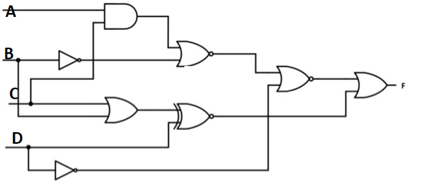

1. Draw the logic diagram for the following function after simplification using k-map,

F(W,X,Y,Z)= m(0,1,8,9)+d(12,13,14,15) as PoS (5)

|  |
| --- |
|  |
|  |
|  |
|  |
|  |
|  |
|  |
|  |
|  |

|  |
| --- |
|  |
|  |
|  |
|  |
|  |
|  |
|  |
|  |
|  |

|  |
| --- |
|  |
|  |
|  |
|  |
|  |
|  |
|  |
|  |
|  |
|  |
|  |
|  |